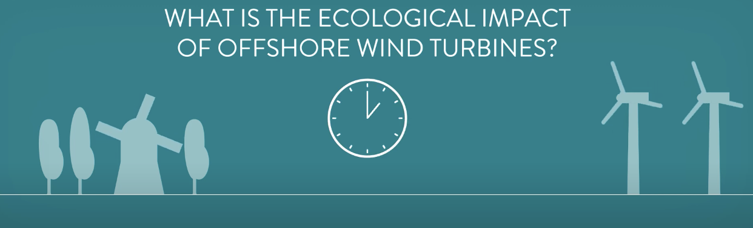

Oral comprehension

I- Listen to the following extract and fill in the gaps:

What is the 1 _ _ _ _ _ _ _ _ _ _ _ 2 _ _ _ _ _ _ _ _ _ _ _ _ of wind turbines?
Wind 3_ _ _ _ _ _ _ _ _ _ _ _ _ _ _ is a relatively clean alternative for 4_ _ _ _ _ _ _ _ _ _ _ fuels as they do not
emit 5_ _ _ _ _ _ _ _ _ _ _ _ gasses during operation.
But they do affect nature in other ways too.
Wind 6_ _ _ _ _ _ _ _ _ _ _ _ affect the 7 _ _ _ _ _ _ _ _ _ _ _ _ migration routes of birds and bats.
And the 8_ _ _ _ _ _ _ _ _ _ _ blades form a deadly hazard for birds.
Then again, it’s proven that wind 9_ _ _ _ _ _ _ _ _ _ _ _ _ form a significantly smaller threat compared to
cats.
Sea life flourishes, due to the absence of fishery near wind farms and the 10_ _ _ _ _ _ _ _ _ _ _ _ _
11_ _ _ _ _ _ _ _ _ _ _ _ _ created by the foundation of the structures can even lead to an increase in
12_ _ _ _ _ _ _ _ _ _ _ _ _ diversity.
Still, the construction of 13_ _ _ _ _ _ _ _ _ _ _ _ _ wind farms 14_ _ _ _ _ _ _ _ _ _ _ noise that poses a
potential threat to 15_ _ _ _ _ _ _ _ _ _ _ and marine mammals like seals and whales.
16_ _ _ _ _ _ _ _ _ _ _ _ _ organizations stress the importance of proper research, careful site selection,
and noise 17_ _ _ _ _ _ _ _ _ _ _ _ _ _ _ _ during installation.
But they also see the potential of concepts for wind farm 18_ _ _ _ _ _ _ _ _ _ _ _ _.
Like 19_ _ _ _ _ _ _ _ _ _ _ seaweed or mussels for human 20_ _ _ _ _ _ _ _ _ _ _ _ _.

II- Find a title for the document.
_ _ _ _ _ _ _ _ _ _ _ _ _ _ _ _ _ _ _ _ _ _ _ _ _
III-Say if the following statements are true or false and always justify:
1-Wind turbines do not emit greenhouse gases during operation.
_ _ _ _ _ _ _ _ _ _ _ _ _ _ _ _ _ _ _ _ _ _ _ _ _ _ _ _ _ _ _ _ _ _ _ _ _ _ _ _ _ _ _ _ _ _ _ _ _
2- Wind turbines have no impact on the migration of birds and bats.
_ _ _ _ _ _ _ _ _ _ _ _ _ _ _ _ _ _ _ _ _ _ _ _ _ _ _ _ _ _ _ _ _ _ _ _ _ _ _ _ _ _ _ _ _ _ _ _ _
3- Marine life thrives near wind farms due to the absence of fishing.
_ _ _ _ _ _ _ _ _ _ _ _ _ _ _ _ _ _ _ _ _ _ _ _ _ _ _ _ _ _ _ _ _ _ _ _ _ _ _ _ _ _ _ _ _ _ _ _ _
4- Artificial reefs created by wind turbine foundations can reduce species diversity.
_ _ _ _ _ _ _ _ _ _ _ _ _ _ _ _ _ _ _ _ _ _ _ _ _ _ _ _ _ _ _ _ _ _ _ _ _ _ _ _ _ _ _ _ _ _ _ _ _
5- Environmental organizations consider research and site selection unimportant for wind farms.
_ _ _ _ _ _ _ _ _ _ _ _ _ _ _ _ _ _ _ _ _ _ _ _ _ _ _ _ _ _ _ _ _ _ _ _ _ _ _ _ _ _ _ _ _ _ _ _ _
6- Offshore wind turbines never generate noise.
_ _ _ _ _ _ _ _ _ _ _ _ _ _ _ _ _ _ _ _ _ _ _ _ _ _ _ _ _ _ _ _ _ _ _ _ _ _ _ _ _ _ _ _ _ _ _ _ _

IV- Find the equivalents in the script of the extract for:
Éventail des espèces
La faune et la flore aquatique
Un risque éventuel
Un gaz à propriétés de réchauffement planétaire
Pêche suspendue
Élevage de micro-algues

V- Traduire du début à : « bird » (ligne 6)

_ _ _ _ _ _ _ _ _ _ _ _ _ _ _ _ _ _ _ _ _ _ _ _ _ _ _ _ _ _ _ _ _ _ _ _ _ _ _ _ _ _ _ _ _ _ _ _ _

_ _ _ _ _ _ _ _ _ _ _ _ _ _ _ _ _ _ _ _ _ _ _ _ _ _ _ _ _ _ _ _ _ _ _ _ _ _ _ _ _ _ _ _ _ _ _ _ _

_ _ _ _ _ _ _ _ _ _ _ _ _ _ _ _ _ _ _ _ _ _ _ _ _ _ _ _ _ _ _ _ _ _ _ _ _ _ _ _ _ _ _ _ _ _ _ _ _

_ _ _ _ _ _ _ _ _ _ _ _ _ _ _ _ _ _ _ _ _ _ _ _ _ _ _ _ _ _ _ _ _ _ _ _ _ _ _ _ _ _ _ _ _ _ _ _ _

_ _ _ _ _ _ _ _ _ _ _ _ _ _ _ _ _ _ _ _ _ _ _ _ _ _ _ _ _ _ _ _ _ _ _ _ _ _ _ _ _ _ _ _ _ _ _ _ _

_ _ _ _ _ _ _ _ _ _ _ _ _ _ _ _ _ _ _ _ _ _ _ _ _ _ _ _ _ _ _ _ _ _ _ _ _ _ _ _ _ _ _ _ _ _ _ _ _

Words in the text | Synonyms | Translations | Results: ex:1-b-5
1- wind turbine  2- artificial  3- offshore  4- near  5- wind farms | a- in proximity  b- wind power installation  c- wind-driven electricity generator  e- located in the sea  f- manufactured | 1- extra-côtiers  2- éoliennes  3- à proximité  4- parcs éoliens  5- artificiels | 1-_ _ _ _ _ _ _ _ _ _ _ _ _  2-_ _ _ _ _ _ _ _ _ _ _ _ _  3-_ _ _ _ _ _ _ _ _ _ _ _ _  4-_ _ _ _ _ _ _ _ _ _ _ _ _  5-_ _ _ _ _ _ _ _ _ _ _ _ _

